**Final Exam**

1. After running my program for 1000 samples I noticed few things for every iteration the C increases. Yes, there is a great penalty. Lastly, we get great penalty for C. So, at this point all the errors decreases. And there is one more thing, when our penalty increases our CV score also increases at the same time. Below is the screen shot for 1000 samples.

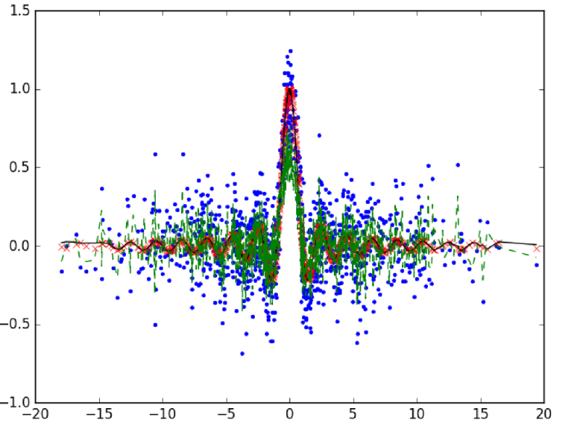

For N = 10000 Samples.

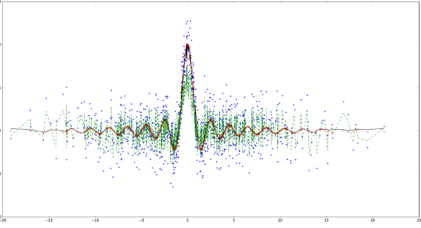

1. After running the program, below is the screen shot for the final plot.

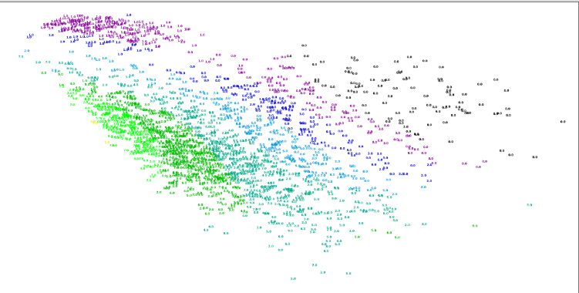

In the above figure, as we see each number is having different color. Some numbers look similar but assigned with different colors. After several iterations, I could find Hyper-parameters. For nearly 267990 the C was 4096, Epsilon was 1.4. and Gamma was 0.0625. And the testing CV score was around 0.33701. Once the CV got tested then all the values are taken as final. Then upon this values we generate the slots.

for every iteration, the C increases. Yes, there is a great penalty. Lastly, we get great penalty for C. So, at this point all the errors decreases